Your name here
My House Ideas

There is much to be considered when planning your house. Please download this document and save it to your Z drive. You will need to find images you like for each section below and add them to this document. Here are some guidelines to help you along:

- When searching for pictures of textures or finishes you like, try adding the words ‘seamless pattern’ or ‘seamless texture’ to your search and click on images to see all of the choices that appear. Download the ones you like to your Z drive for use in this document.
- If you are looking to add a swatch of plain color to this document, try using the shapes tool and filling it with the color of your choice.
- You should resize all of your texture and finishes images so that they are almost or exactly the same size.
- Images of floor plans, outside/inside views, and landscaping should be lined up with each other on the page.
- Keep in mind that this is a planning document and therefore a starting point for your house project. If you change your mind later, that is ok.
- Below are sections you need to populate with your own ideas. The pictures and text (except headings) already there should be deleted and your own should be added.
- Make sure your document is complete and ready to print. You will be printing it in color on Friday after we edit out the directions and extra text.

Outside Finishes
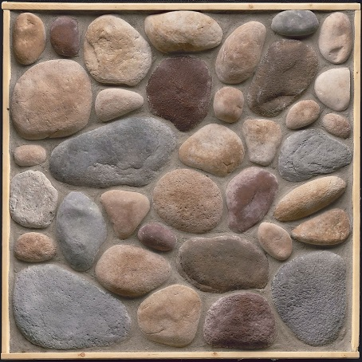

Inside Wall Colors

Floor Finishes
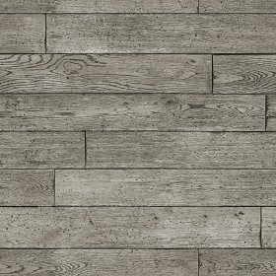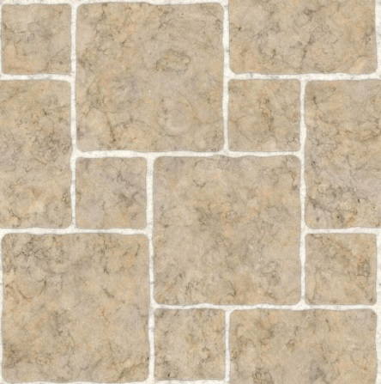

Roof Material
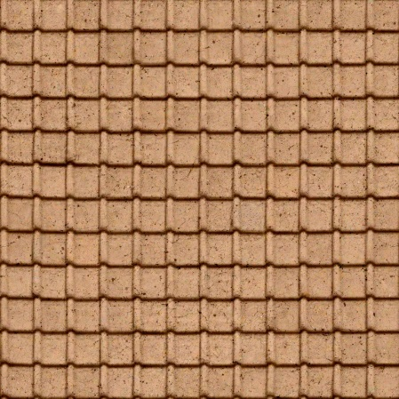

Floor Plan

Please search for ‘floor plans’ in google images. Take a look for one(s) you like and save the image. Insert the image in place of this text. You may add more than one image if you like.

Outside House Image

Search for an image you like of the outside of a house and insert it in place of this text. You may add more than one image if you like.

Inside House Images

Find three images you like of the inside of a house and insert them in place of this text.

Landscape

Search for an image you like of residential landscape (around a single family house) and insert the image in place of this text. You may add more than one image if you like. Feel free to add images of specific trees or flowers you like.

