Create custom title block
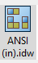

Open a new ANSI drawing file, locate sheet 1, under sheet 1 locate the ANSI Large title block. Right click and delete it.

Open the drawing resources folder, locate the title blocks folder. Open the folder the reveal the ANSI-Large and ANSI A Title Blocks.

Right Click on ANSI A - Select Edit from the menu.

Edit mode:

In edit mode you are able to create a custom Title Block. Erase the title block in the edit space currently. Draw the new Form as seen below using the dimensions given.
The bottom row information can over-lap in edit mode.
Date: <Creation Date>
Scale: <Initial View Scale>
Sheet No.: <Sheet: Number>

Use Text to create the Titles. Remember to use capital letters.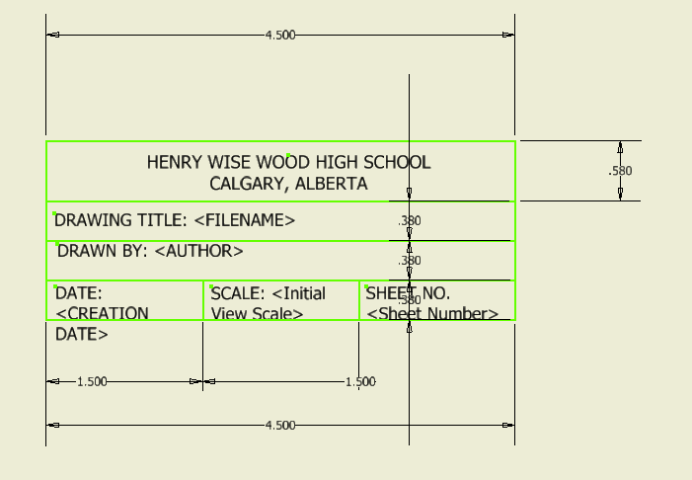

Use Text to create the Titles. Remember to capitalize the letters

Use annotate to create balloons, as well as an item list.

